**Logic gate (2)**

**Name _______class______**

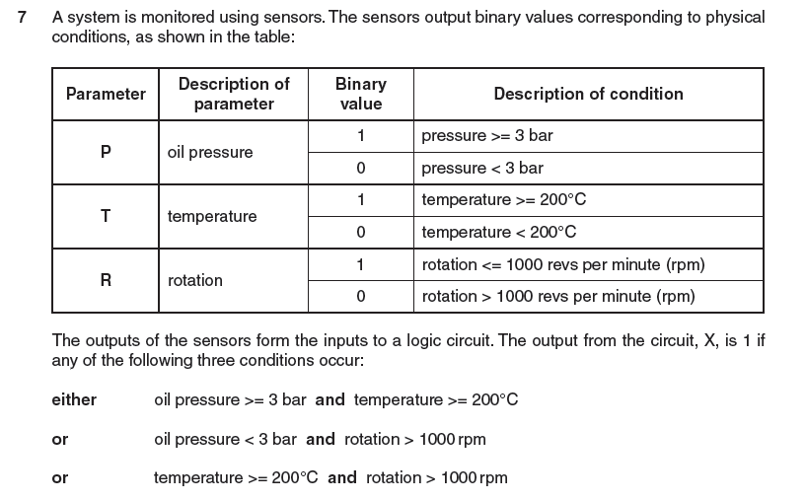

1

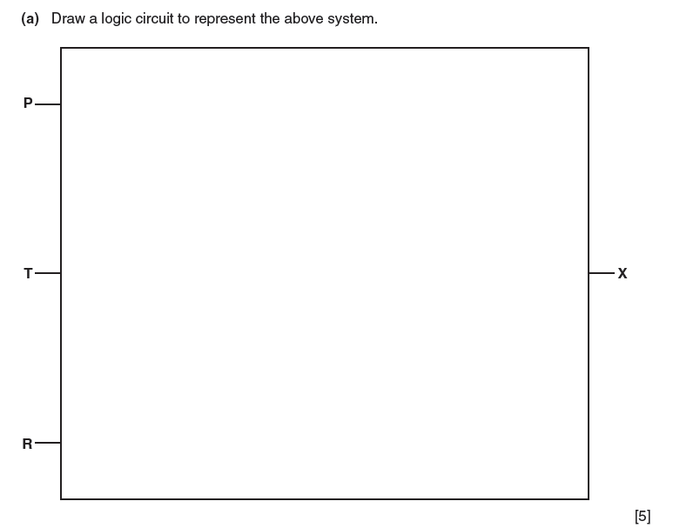

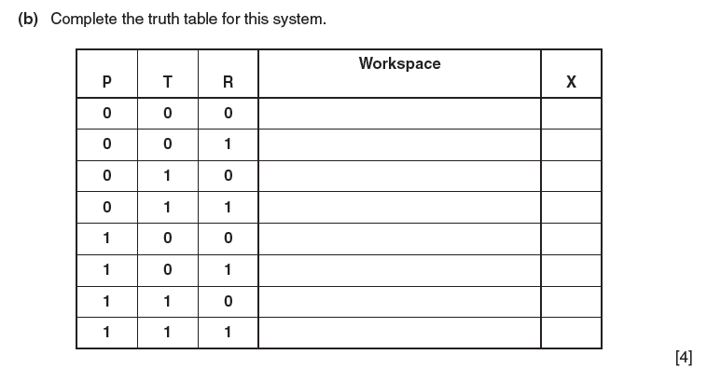

4. Implementing Circuits from Boolean Expressions and construct the truth table

* X = AC+BC’+A’BC

|  |  |  |  |
| --- | --- | --- | --- |
| A | B | C | X |
|  |  |  |  |
|  |  |  |  |
|  |  |  |  |
|  |  |  |  |
|  |  |  |  |
|  |  |  |  |
|  |  |  |  |
|  |  |  |  |

* x = AB+B’C

|  |  |  |  |
| --- | --- | --- | --- |
| A | B | C | X |
|  |  |  |  |
|  |  |  |  |
|  |  |  |  |
|  |  |  |  |
|  |  |  |  |
|  |  |  |  |
|  |  |  |  |
|  |  |  |  |

* x=(A+B)(B’+C)

|  |  |  |  |
| --- | --- | --- | --- |
| A | B | C | X |
|  |  |  |  |
|  |  |  |  |
|  |  |  |  |
|  |  |  |  |
|  |  |  |  |
|  |  |  |  |
|  |  |  |  |
|  |  |  |  |